Serving the Wide Bay Burnett Area since 1970

Shop 2 Melory Place, 53 Torquay Road,
Pialba, Hervey Bay Q 4655
Ph: 07 41244420
Email: info@morgansewingcentre.com
Website: www.morgansewingcentre.com

THE MORGAN STITCH UP – FEBRUARY/MARCH, 2026
OUR HOURS ARE
9 AM – 5 PM MONDAY – FRIDAY
9AM – 12 NOON – SATURDAY

PHILL’S MOBILE MACHINE SERVICING
Maryborough, Bundaberg, Gin Gin, Childers, Gladstone, Rockhampton, Yeppoon, Emu Park, Biloela, Murgon,
Gayndah, Mundubbera, Eidsvold, Monto and Biggenden.
(including Industrial Machines)
He can also organise to set up at your Craft or Quilting Group if you have multiple machines to be serviced.

FEBRUARY, 2026
GIN GIN/BUNDABERG Saturday, 7th
MONTO/GAYNDAH Tuesday, 17th/Wednesday, 18th
MARCH, 2026
GIN GIN/BUNDABERG Saturday, 7th
GLADSTONE Tuesday, 24th
BILOELA Wednesday, 25th
ROCKHAMPTON Thursday, 26th and Friday, 27th
EMU PARK Saturday, 28th
YEPPOON Sunday, 29th

--These dates are subject to change so please call to confirm

CLASSES AND WORKSHOPS:

Social Sit and Sew classes – 2nd and 4th Thursdays. 9.30am – 1.30pm. BYO project. Limited to 8 so book in early as places are filling fast.

TEST DRIVE: BROTHER CELESTE CX1 – 19th March.

MACHINE SPECIALS:

NEW: BROTHER AVENEER EV RRP $24999 – Ask Phill about a Special Price. https://www.brother.com.au/en/sewing-machines/all-sewing-machines/aveneer-ev1
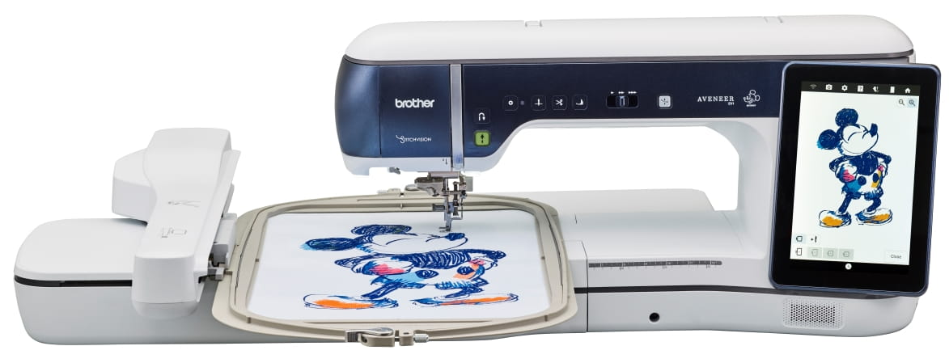
BROTHER Stellaire XE2 EMBROIDERY ONLY - $9999
https://www.brother.com.au/en/products/all-sewing-machines/sewing-machines/stellaire-innov-is-xe1

NEW: BROTHER Celeste CX1e EMBROIDERY ONLY - $6999

https://www.brother.com.au/en/sewing-machines/all-sewing-machines/cx1e

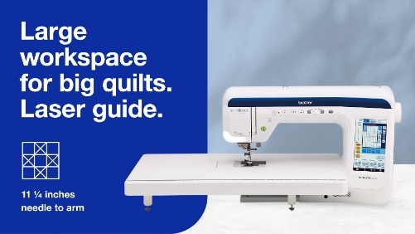
BROTHER BQ3100 – RRP $5299
Sewing & Quilting Machine BQ3100 | Brother Australia

BROTHER 1800Q – RRP $1999
Sewing & Embroidery Machine Innov-is NV1800Q | Brother Aust

BROTHER A150 – RRP $999 Sewing Machine Innov-is A150 | Brother Australia

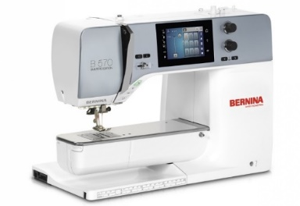
VIEW THE RANGE OF BERNINA SEWING, QUILTING AND EMBROIDERY MACHINES HERE: BERNINA: Premium Swiss quality sewing machines - BERNINA

JANOME CM17
RRP $24999-
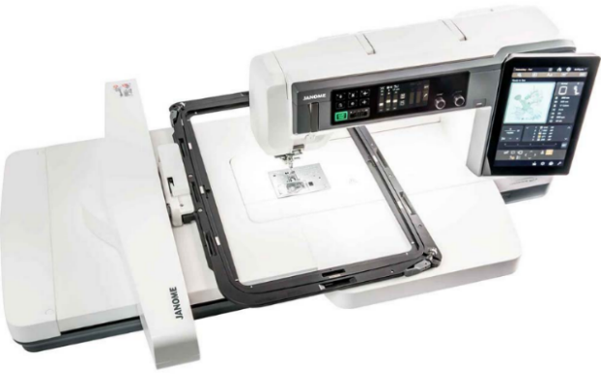
Special Limited Time Offer $16999
Continental-M17-Info-Brochure.pdf (janome.com.au) Janome Continental M17

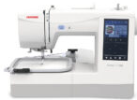
NEW:
JANOME MC100E Embroidery only machine RRP $1499
https://janome.com.au/product/memory-craft-100e/
AND JANOME MC1000 Sewing/Embroidery machine
RRP $1999 https://janome.com.au/product/memory-craft-1000/

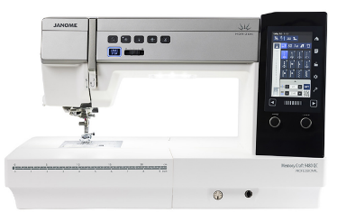
JANOME MC9480 QC – RRP $8999 – Sale Price $6999
Horizon Memory Craft 9480 QC Professional - Janome

CM6 $5999 AND JANOME CM8 $9999
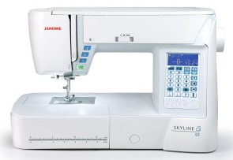
JANOME SKYLINE S3 AE – RRP $2999 – Now only $1599
Skyline S3 - Janome

JANOME SKYLINE S5 AE – RRP $23999 – Now only $1999
https://janome.com.au/product/skyline-s5ae/

JANOME MC9850 SEWINGING AND EMBROIDERY MACHINE – ONLY $3999 https://janome.com.au/product/memory-craft-9850/
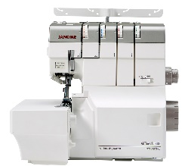

JANOME AT2000D AIR THREAD OVERLOCKER RRP $2400
Sale Price $1499 http://janome.com.au/product/at2000d-professional/

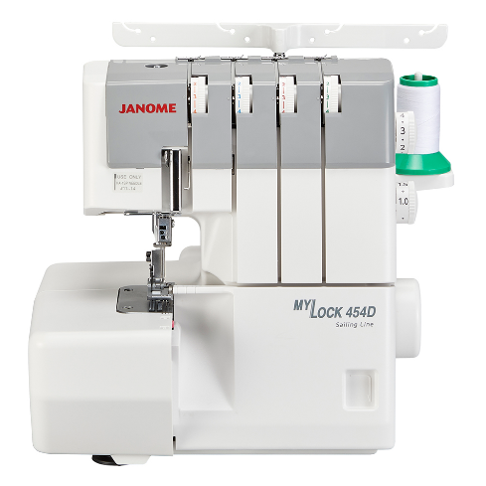
NEW Janome MyLock 454D Overlocker!
RRP $1149 Sale Price $699

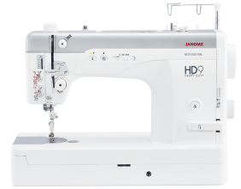
JANOME HD-9 HEAVY DUTY SEWING MACHINE
$2999 https://janome.com.au/product/hd9/

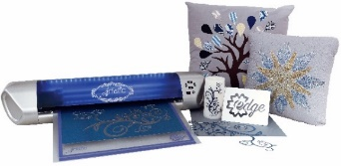
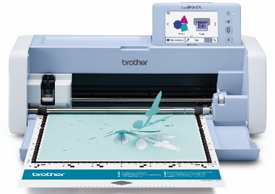
CUTTING MACHINES

https://www.brother.com.au/brochures/SDX1200_Brochure.pdf
https://janome.com.au/product/artistic-edge-cutters/

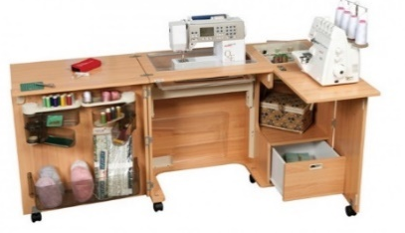
HORN SEWING FURNITURE
https://www.horn.com.au/

