

Serving the Wide Bay Burnett Area since 1970

**Shop 2 Melory Place, 53 Torquay Road,**

**Pialba, Hervey Bay Q 4655**

**Ph/Fax: 07 41244420**

**Email:** info@morgansewingcentre.com

**Website:** www.morgansewingcentre.com

**THE MORGAN STITCH UP – FEBRUARY/MARCH, 2020**

**BROTHER MACHINES - THE NEW FOR 2020 LINEUP**

**Find all the info here:** <https://www.brother-usa.com/home/sewing-embroidery/new-for-2020>

**XJ1 EMBROIDERY & SEWING COMBO - $11999**

<https://www.brother.com.au/en/products/all-sewing-machines/sewing-machines/stellaire-innov-is-xj1>

**OR XE1 EMBROIDERY ONLY - $8999**

<https://www.brother.com.au/en/products/all-sewing-machines/sewing-machines/stellaire-innov-is-xe1>

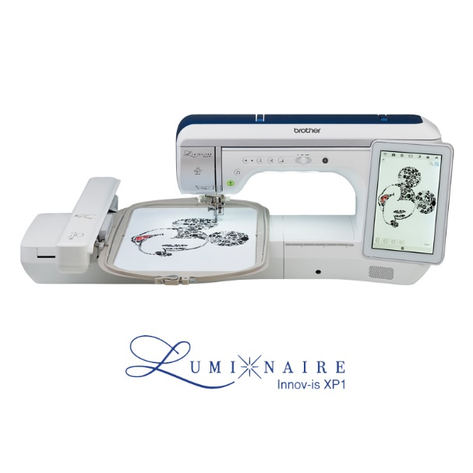**BROTHER Luminaire Innov-is XP1**

**RRP $19,999**

<https://www.brother.com.au/en/home/all-sewing-machines/sewing-machines/luminaire-innov-is-xp1>

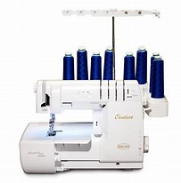**Babylock OVATION (floor stock- new in box)**

**RRP $5995 – Sale Price $4299 (one only)**

<http://www.babylock.com.au/overlockers-coverstitch/ovation>

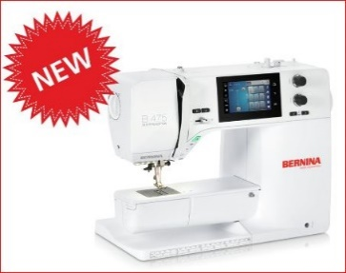

**BERNINA 4 Series – Now Available in store.** <https://www.bernina.com/en-AU/Machines-AU/Series-Overview/NEW-BERNINA-4-Series/BERNINA-475-QE>

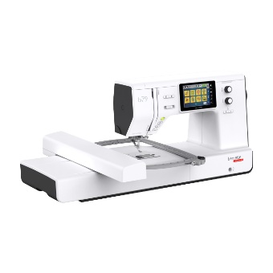**NEW - BERNETTE B79 SEWING/EMBROIDERY MACHINE - $2999** <https://www.berninaonline.ca/store/bernette79/>

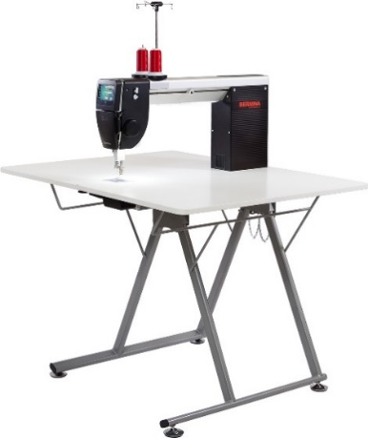

**BERNINA Q24 AND Quilt Frame**

**and Sit Down Quilting Packages Available.**

**BERNINA Q20 with NEW Folding Table - $11499**

<https://www.bernina.com/en-AU/Products-AU/BERNINA-products/Longarm-Quilting>

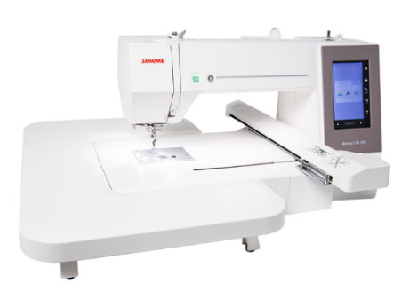 **JANOME MC550E EMBROIDERY ONLY MACHINE – RRP $4999 – NOW $3999 with BONUS ARTISTIC DIGITIZING PROGRAM!**

<https://janome.com.au/product-category/embroidery-machine/?s=550>

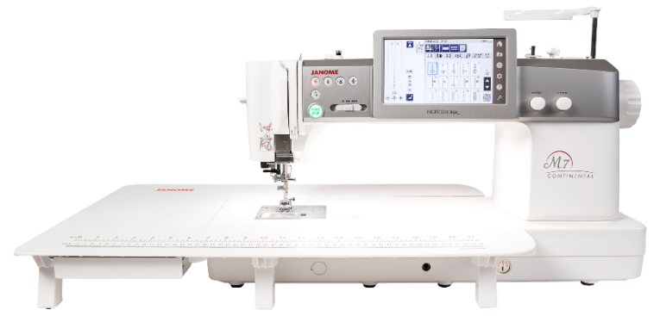

**NEW - JANOME CM7P SEWING/QUILTING MACHINE - RRP$6999** <https://janome.com.au/product/cm7p/>

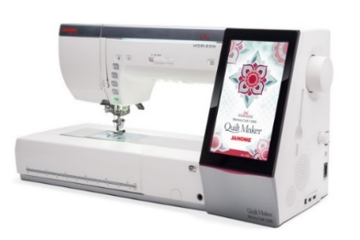**JANOME HORIZON QUILT MAKER 15000 V3** <http://www.janome.com.au/product/horizon-quilt-maker-memory-craft-15000/>

**JANOME MC6650P SEWING/QUILTING MACHINE – $2499 – Save $300!** <https://janome.com.au/wp-content/uploads/2019/07/20965-AW-Janome-MC6650-brochure.pdf>

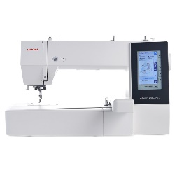

**JANOME MC500 EMBROIDERY ONLY MACHINE (floor stock only) $2999 – one only**

<http://www.janome.com.au/product/memory-craft-500e/>

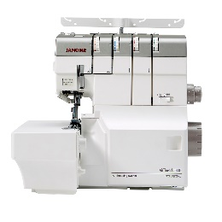

**JANOME AT2000D AIR THREAD OVERLOCKER $1699** <http://janome.com.au/product/at2000d-professional/>

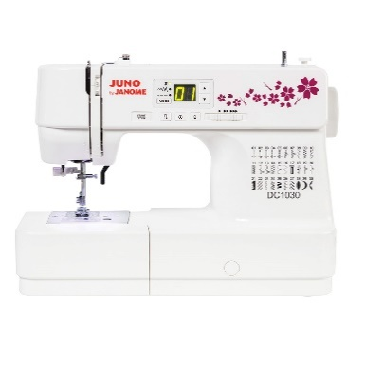

**JANOME DC1030 –RRP399 – NOW $299** <http://janome.com.au/product/dc1030/>

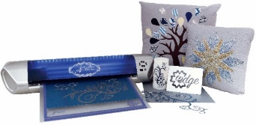

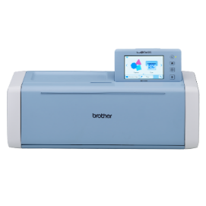**CUTTING MACHINES from $399(12” Artistic Edge)**

<https://www.brother.com.au/brochures/SDX1200_Brochure.pdf>

<https://janome.com.au/product/artistic-edge-cutters/>

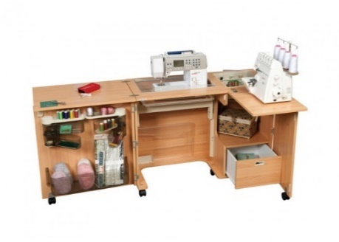

**HORN SEWING FURNITURE**

<https://www.horn.com.au/horn-modular-range>

**PHILL’S MOBILE MACHINE SERVICING IS AVAILABLE at Maryborough, Gympie, Bundaberg, Gin Gin, Childers, Gladstone, Murgon, Gayndah, Mundubbera, Eidsvold, Monto and Biggenden.**

**(includes Industrial Machines)**

**He can also organise to set up at your Craft or Quilting Group if you have multiple machines to be serviced. Please see the calendar at the end of the Newsletter for the dates when Phill will be in these areas.**

**CREATIVE SEWING CLUB**

**1st Wednesday of every month,** demonstration only to suit all makes and models of sewing and embroidery machines and overlockers, with notes provided on tips & techniques. Show & Tell & more. **TWO SESSIONS: 9:30am – 11:30am OR 1:00pm – 3:00pm - COST: $40.00 per year,** giving you entitlements to in-store discounts. If you don’t want to join the Club, just pay $5 each time you attend a demonstration...this casual attendance excludes the 10% in-store discounts.

**MACHINE EMBROIDERY CLASSES – FRIDAYS (9am-1pm) and SATURDAYS (12.30-4pm) with Adele - $20.** Join in at this hands-on class for BEGINNERS and ADVANCED Embroiderers, who wish to use their machine to it’s full capability.

**BEGINNER BASIC MACHINE EMBROIDERY CLASSES (for SMALL HOOP machines) – Third Wednesday of the month (9am- 1pm) with Rosie - $30 - $10 Deposit on booking – Requirements List provided when deposit is paid.** Learn your machine and use the inbuilt designs on your embroidery machine to make small projects. This class is very popular, so book in quick!

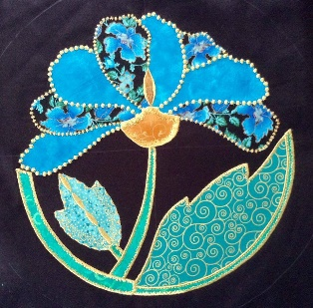**APPLIQUE CLASSES – with Rosie - 9am – 1pm - $30. First and Last Thursday of each month.** Projects include Geisha Girl, Lorikeet wall hanging, Japanese bed runner and UFO’s.

$10 Deposit required when booking. Requirement List provided with deposit.

**BASIC FREE MOTION WORKSHOP – with Rosie – Date to be advised – 9am – 1.30pm $30 per Class.**

**OVERLOCKER CLUB – 9AM – 11AM - Third Thursday of the month - $20 per Class + $10 kit. Starts May, 2020 for 6 months.** Join these classes to use your overlocker for more than just finishing seams. We explore different techniques and feet to create the complete project on the overlocker. You must book in for these classes and please pay a deposit so we know how many kits to cut.

**[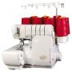](http://www.babylock.com.au/products/view/Evolve/)**

**BASIC OVERLOCKER WORKSHOP – with Robyn – Wednesdy, 25th March - 9am – 3pm - $60 –** A hands-on workshop where you learn how to master your overlocker! In the morning we go through threading, general over locking techniques and what all the buttons and dials are for. In the afternoon we make a small bag using rolled hem, pintucks and gathering. All fabric is supplied. Book Now and pick up your Requirements List for this informative workshop.

**CHILDREN’S LEARN TO SEW CLASSES - AGE LIMIT 10 YEARS – with Rosie – Thursdays - 3.15-5.15 pm – 23rd and 30th April and 7th and 14th May.**

All fabric and thread supplied.

From $60 per week for 4 weeks – includes the purchase of a new sewing machine to take home on completion of the course and full payment of the sewing machine. (ie. RE1306 - $199 while available.)

**Option 2** - $25 per week (with own sewing machine) for 4 weeks.

Learn threading, beginner sewing techniques and make a project.

Happy Sewing! Phill, Amie, Robyn, Rosie, Adele, Kaylene, Fran, Karina & Josh



PLEASE SCROLL DOWN TO VIEW OUR LATEST CLASS LIST CALENDARS

|  | **Class List February 2020** | | | | |  |
| --- | --- | --- | --- | --- | --- | --- |
| **Sun** | **Mon** | **Tue** | **Wed** | **Thu** | **Fri** | **Sat** |
| Shop 2 Melory Place,  53 Torquay Road,  Pailba, Hervey Bay, Q. 4650  Ph: 41244420 | | | | | | 1  MACHINE  EMBROIDERY  PROJECTS  12.30pm – 4pm $20 |
| 2 | 3 | 4 | 5  **CREATIVE SEWING CLUB 9.30-11.30 AM**  **1-3 PM**  **SCISSOR SHARPENING SERICE TODAY!** | 6  **APPLIQUE**  **9AM – 1PM $30** | 7  MACHINE  EMBROIDERY  PROJECTS  9AM – 1 PM $20 | 8  MACHINE  EMBROIDERY  PROJECTS  12.30pm – 4pm $20 |
| 9 | 10 | 11 | 12 | 13  PHILL AT  Monto, Mundubbera, Eidsvold, Gayndah, Biggenden  PHILL’S BUSH TRIP Gayndah Mundubbera Biggenden | 14  MACHINE  EMBROIDERY  PROJECTS  9AM – 1 PM $20 | 15  MACHINE  EMBROIDERY  PROJECTS  12.30pm – 4pm $20 |
| 16 | 17 | 18  PHILL AT  Murgon | 19  BASIC  MACHINE  EMBROIDERY  PROJECTS  9am – 1pm $30 | 20 | 21  MACHINE  EMBROIDERY  PROJECTS  9AM – 1 PM $20  PHILL AT  Gympie  PHILL AT  Gympie  PHILL AT  Gympie | 22  MACHINE  EMBROIDERY  PROJECTS  12.30pm – 4pm $20 |
| 23 | 24 | 25 | 26 | 27  **APPLIQUE**  **9AM – 1PM $30** | 28  MACHINE  EMBROIDERY  PROJECTS  9AM – 1 PM $20 | 29  MACHINE  EMBROIDERY  PROJECTS  12.30pm – 4pm $20 |

|  | **Class List March, 2020** | | | | |  |
| --- | --- | --- | --- | --- | --- | --- |
| **Sun** | **Mon** | **Tue** | **Wed** | **Thu** | **Fri** | **Sat** |
| 1 | 2 | 3 | 4  **CREATIVE SEWING CLUB 9.30-11.30 AM**  **1-3 PM** | 5  **APPLIQUE**  **9AM – 1PM $30** | 6  MACHINE  EMBROIDERY  PROJECTS  9AM – 1 PM $20 | 7  MACHINE  EMBROIDERY  PROJECTS  12.30pm – 4pm $20  PHILL AT  Gin Gin Bundaberg |
| 8 | 9 | 10 | 11 | 12 | 13  MACHINE  EMBROIDERY  PROJECTS  9AM – 1 PM $20 | 14  MACHINE  EMBROIDERY  PROJECTS  12.30pm – 4pm $20 |
| 15 | 16 | 17 | 18  BASIC  MACHINE  EMBROIDERY  PROJECTS  9am – 1pm $30 | 19 | 20  MACHINE  EMBROIDERY  PROJECTS  9AM – 1 PM $20  PHILL AT  Gympie | 21  MACHINE  EMBROIDERY  PROJECTS  12.30pm – 4pm $20 |
| 22 | 23 | 24  PHILL AT  Gladstone | 25  **BASIC OVERLOCKER WORKSHOP 9AM – 3PM $60** | 26  **APPLIQUE**  **9AM – 1PM $30** | 27  MACHINE  EMBROIDERY  PROJECTS  9AM – 1 PM $20 | 28  MACHINE  EMBROIDERY  PROJECTS  12.30pm – 4pm $20 |
| 29 | 30 | 31 | Shop 2 Melory Place,  53 Torquay Road,  Pailba, Hervey Bay, Q. 4650  Ph: 41244420 | | | |

|  | **Class List April, 2020** | | | | |  |
| --- | --- | --- | --- | --- | --- | --- |
| **Sun** | **Mon** | **Tue** | **Wed** | **Thu** | **Fri** | **Sat** |
|  | | | 1  **CREATIVE SEWING CLUB 9.30-11.30 AM**  **1-3 PM** | 2  **APPLIQUE**  **9AM – 1PM $30** | 3  MACHINE  EMBROIDERY  PROJECTS  9AM – 1 PM $20 | 4  MACHINE  EMBROIDERY  PROJECTS  12.30pm – 4pm $20 |
| 5 | 6 | 7 | 8 | 9  PHILL AT  Monto, Mundubbera, Eidsvold, Gayndah, Biggenden  PHILL’S BUSH TRIP Gayndah Mundubbera Biggenden | 10  **GOOD FRIDAY** | 11  **EASTER SATURDAY** |
| 12  **EASTER** | 13  **EASTER MONDAY** | 14 | 15  BASIC  MACHINE  EMBROIDERY  PROJECTS  9am – 1pm $30 | 16 | 17  MACHINE  EMBROIDERY  PROJECTS  9AM – 1 PM $20 | 18  MACHINE  EMBROIDERY  PROJECTS  12.30pm – 4pm $20 |
| 19 | 20 | 21 | 22 | 23  **KIDS CLASS 3.15-5.15PM**  **$25** | 24  MACHINE  EMBROIDERY  PROJECTS  9AM – 1 PM $20 | 25  **ANZAC DAY** |
| 26 | 27 | 28 | 29 | 30  **APPLIQUE**  **9AM – 1PM $30**  **KIDS CLASS 3.15-5.15PM**  **$25** | Shop 2 Melory Place,  53 Torquay Road,  Pailba, Hervey Bay, Q. 4650  Ph: 41244420 | |

When Booking Classes:

Please book ALL classes in advance – Except Creative Sewing Club and Adele’s Machine Embroidery Classes.

A $10 Deposit is required upon booking to receive the Requirements List and ensure your place.

Any remaining fees are to be paid one week prior to class so we can let people know if the class has to be cancelled due to lack of numbers.

A full refund will be provided in these circumstances if the class has been paid for in advance.

Class fees cannot be transferred or refunded if you cancel a booking within this period (regrettably even in the case of illness) as we are committed to run the class for others who have already bought their supplies.

Where kits are required for a Class, the Kits must be ordered and paid for in advance. No refund will be made for the kit if the class is cancelled due to lack of numbers. We will re-schedule the class so you can use the kit.